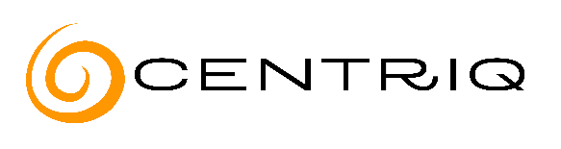

Centriq Diversity in Tech Scholarship

First Name:
Last Name:
Phone Number:
Email Address:
Date of Birth:
City, State:
I Identify as the following  (select all that apply): | ☐ Person of color  ☐ Indigenous person  ☐ Person living with a disability (as defined by WHO)  ☐ Person who identifies as 2SLGBTQIA+  ☐ Person who identifies as a Woman
Secondary Education Status: | ☐ I have earned a high school diploma  ☐ I have earned a GED  ☐ I have not earned a high school diploma or GED
Felon Status: | ☐ I have been convicted of violent felony  ☐ I have been convicted of a non-violent felony  ☐ I have never been convicted of a felony
Program of Interest: | ☐ Cloud & Security Specialist (on-site)  ☐ Cloud & Security Specialist (online)  ☐ Full Stack Web Developer
Desired Program Start Month: | ☐ October 2023  ☐ November 2023  ☐ December 2023  ☐ January 2024
How Did You Hear About Our Diversity in Tech Scholarship?

